Multi-Site Reproducibility Trial of MALDI-IHC Multiplexed Targeted Protein Imaging using a 33-Organ Tissue Microarray

Authors
Catelynn C Shafer¹; Joseph H Holbrook²; Catherine A Kita³; Gargey B. Yagnik³; Mark J. Lim³; Kenneth J. Rothschild^{3, 4}; Katherine A. Stumpo⁵; Erin H. Seeley⁶; Elizabeth K Neumann⁷; Amanda B. Hummon⁸
View Session Details

Institutes
¹University of California Davis, Davis, CA; ²The Ohio State University, Columbus, OH; ³AmberGen Inc., Billerica, MA; ⁴Boston University, Department of Physics and Photonics Center, Boston, MA; ⁵Bruker Daltonics GmbH & Co. KG, Billerica, MA; ⁶University of Texas - Austin, Austin, TX; ⁷University of California, Davis, Davis, California; ⁸The Ohio State University, Columbus, OH

Introduction
Spatial analysis of biological tissue systems using mass spectrometry is well established for small molecules, lipids, and glycans. Recently, the MALDI-IHC workflow, based on antibodies conjugated to novel photocleavable peptide mass-tags, was introduced to fill the unmet need of intact protein spatial analysis by mass spectrometry. Examples of this workflow in cancer and neurological research have been demonstrated by researchers in the past two years. However, no study on the reproducibility of the method has been undertaken. Here, updated sample preparation protocols are deployed at four sites, with an assessment of site-to-site and sample-to-sample reproducibility.

Methods
A formalin-fixed and paraffin-embedded (FFPE) 33-core normal human organ tissue microarray (TMA) from Tissue Array (Derwood, MD) on glass slides underwent deparaffinization, rehydration, antigen retrieval, blocking, incubation with 15 antibodies labeled with novel photocleavable mass-tags (AmberGen, Billerica, MA), and washing. Photocleavage of the mass-tags was performed using a UV-light box prior to coating with CHCA matrix spiked with an internal peptide standard, using an HTX M3+ Sprayer, and finally followed by matrix recrystallization. Each site acquired images using a Bruker timsTOF fleX MALDI mass spectrometer (Bruker, Billerica, MA) with beam scans set to 16 µm and a 20 µm pitch. Experimental design consisted of sequentially sectioned slides that were randomized for all 4 sites, with 3 technical replicates at each site. Antibodies were chosen to cover all tissues in the TMA but were not specific to every core.
In an effort to reduce bias towards any site, data was randomized for sites A through D, and were visualized using the Bruker SCiLS™ Lab software suite. Individual channels were RMS normalized and intensities scaled for each measurement individually.

Results and Discussion
Mass spectrometry groups from the University of California at Davis (Neumann Lab), The Ohio State University (Hummon Lab), the University of Texas at Austin (Seeley Lab), and AmberGen performed the MALDI-IHC workflow on a 33 organ TMA comprised of FFPE human tissue cores. Reproducibility was assessed based on histological patterns and signal intensity. Each site was able to detect all mass-tags associated with 15 protein targets, at high signal-to-noise ratios and with adequate sensitivity. This enabled visualization of the expected histological structures across the TMA and demonstrates the application of these probes to 33 different organs. See Figure 1 for representative data across the four sites.
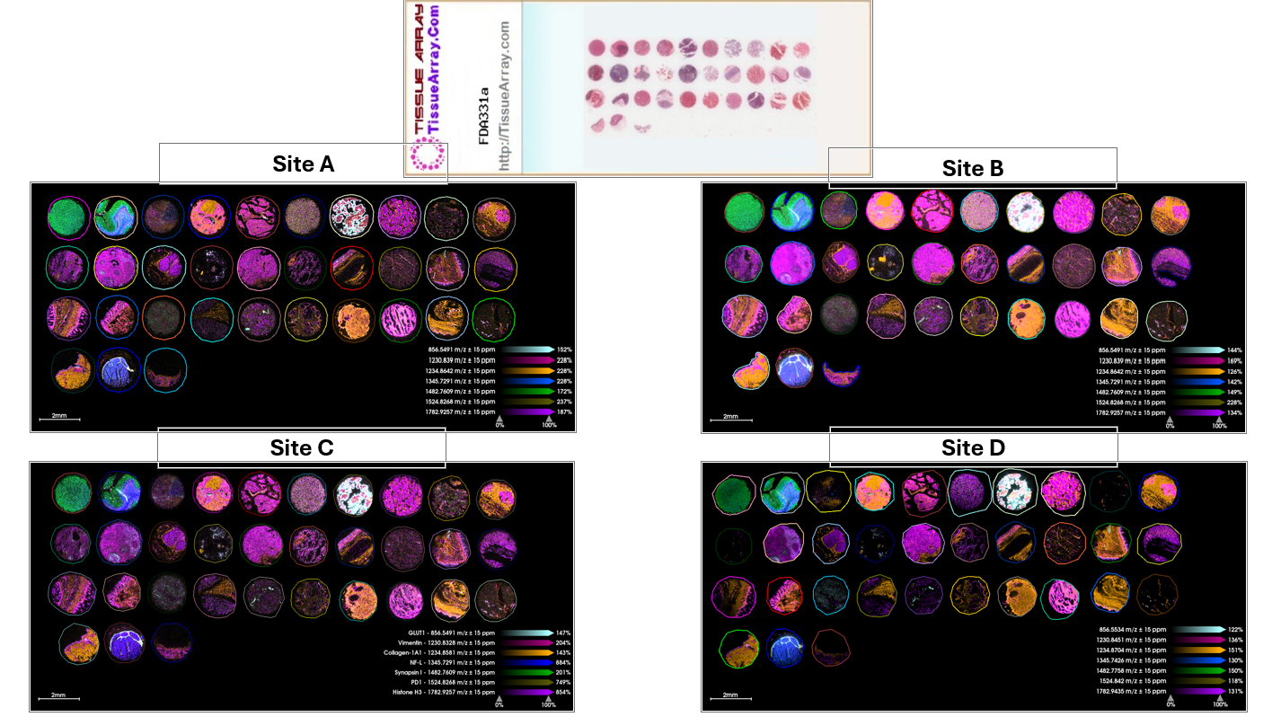
Figure 1. Summary of seven protein markers across all four sites, with a representative H&E-stained slide for reference.
For example, the markers GFAP, Synapsin I, and NF-L were appropriately selective for neurological tissues, whereas the negative control of E-cadherin for neurological tissue was not found, but in contrast was detected in a range of epithelial-containing organs. In another example, CD20 containing B-cells were selectively detected in immune tissues such as spleen, tonsil, thymus, and lymph node. Notably, MALDI-IHC allowed fast (~3 hr/cm ² at 20 µm) and highly multiplexed imaging of the TMAs since all antibodies are added simultaneously followed by one round of MALDI imaging to detect all mass-tags. Through this work, we established the specificity and reproducibility of the approach, determined areas where further optimization is necessary, and validated the use of MALDI-IHC at these four sites.
In conclusion, staining protocols were internally consistent within each site. Staining protocol was consistent across 3 of the 4 sites. Further examination of the source data and method suggests a modification in instrument method parameters that reduced the noise threshold, leading to an outlier. This additionally suggests that consistent methods and careful tuning are important to maintain reproducibility.
Future directions include the multi-site assessment of fresh frozen tissue and multiomic workflows comprising MALDI imaging of untargeted label-free small molecules combined with MALDI-IHC for targeted protein imaging, on the same tissue section using the same mass spectrometry platform.

Novel Aspect
We established reproducibility of MALDI-IHC through a multi-site study to analyze spatial proteomic data.
Conflict of Interest Disclosure
The authors declare the following competing financial interest(s): C.A.K., G.Y., M.J.L., and K.J.R. are current employees of AmberGen, Inc., 44 Manning Road, Billerica, MA 01821, USA. K.S. is currently employed by Bruker Scientific, Billerica, MA.

